CELEBRATIONS C1

Celebrations are an intrinsic part of human culture, transcending geographical boundaries and historical eras. They serve not only as a means of marking significant events but also as a way to foster social cohesion and collective identity. This essay delves into the multifaceted nature of celebrations, exploring their cultural, social, and psychological impacts.  
  
At the heart of any celebration lies its cultural significance. Across the globe, festivals and holidays are deeply embedded in the traditions and histories of societies. For instance, Diwali in India, Christmas in the Western world, and Chinese New Year in East Asia each hold unique cultural meanings and are celebrated with distinct customs. Diwali, the festival of lights, symbolizes the triumph of good over evil and is marked by the lighting of oil lamps, fireworks, and the exchange of sweets. Christmas, celebrating the birth of Jesus Christ, involves a myriad of traditions such as decorating Christmas trees, exchanging gifts, and attending church services. Chinese New Year, also known as the Spring Festival, involves family reunions, feasting, and the giving of red envelopes for good luck. These celebrations provide a sense of continuity and belonging, linking present generations with their ancestral roots.  
  
From a social perspective, celebrations play a crucial role in strengthening community bonds. They provide opportunities for people to come together, reinforcing social ties and creating a sense of unity. Whether it is a national holiday, a religious festival, or a personal milestone such as a wedding or a birthday, celebrations foster interaction and communication. They allow individuals to express their cultural identities and share their heritage with others, promoting understanding and tolerance in increasingly diverse societies. For example, public holidays like Thanksgiving in the United States or Bastille Day in France are occasions for communities to come together in shared commemoration and festivity.  
  
Psychologically, celebrations have significant benefits. They offer a break from the routine, providing an opportunity for relaxation and enjoyment, which can reduce stress and improve mental health. The anticipation of a celebration can be just as exciting as the event itself, offering something to look forward to and creating positive emotional states. Celebrations also provide a platform for the expression of joy and gratitude, which can enhance overall well-being. Studies have shown that engaging in celebratory activities can increase feelings of happiness and life satisfaction, as they allow individuals to reflect on their achievements and the positive aspects of their lives.  
  
However, it is also important to consider the potential downsides of celebrations. Commercialization has, in some cases, overshadowed the original meanings of many festivals. Christmas, for instance, has increasingly become associated with consumerism, often overshadowing its religious and cultural significance. Moreover, the pressure to conform to societal expectations during celebrations can sometimes lead to stress rather than enjoyment. Financial strain from spending on gifts, decorations, and festivities can also be a significant burden for many individuals.  
  
In conclusion, celebrations are a vital aspect of human life, rich with cultural, social, and psychological significance. They serve to preserve traditions, strengthen community bonds, and enhance individual well-being. Despite the challenges posed by commercialization and societal pressures, the essence of celebration as a means of joy, unity, and cultural expression remains deeply embedded in the human experience. As we continue to navigate the complexities of modern life, the fundamental need to come together and celebrate remains as pertinent as ever.

|  |  |
| --- | --- |
|  |  |

LET’S TALK ABOUT CELEBRATIONS

1. Cultural Significance:  
   - What are some examples of celebrations mentioned in the essay, and what cultural meanings do they hold?  
   - How do celebrations like Diwali, Christmas, and Chinese New Year connect present generations with their ancestral roots?  
  
2. Social Impact:  
   - In what ways do celebrations strengthen community bonds?  
   - Provide examples of how public holidays can bring communities together.  
  
3. Psychological Benefits:  
   - What are some psychological benefits of participating in celebrations?  
   - How can the anticipation of a celebration affect an individual's emotional state?  
  
4. Challenges and Downsides:  
   - What is one potential downside of the commercialization of celebrations?  
   - How can societal expectations during celebrations lead to stress?  
  
5. General Understanding:  
   - Summarize the main points discussed in the essay about the importance of celebrations.  
   - Why is the need to celebrate considered pertinent in modern life, according to the essay?  
  
6. Critical Thinking:  
   - Do you agree with the essay's assertion that celebrations are essential for individual and social well-being? Why or why not?  
   - How can communities balance the traditional significance of celebrations with the pressures of commercialization?

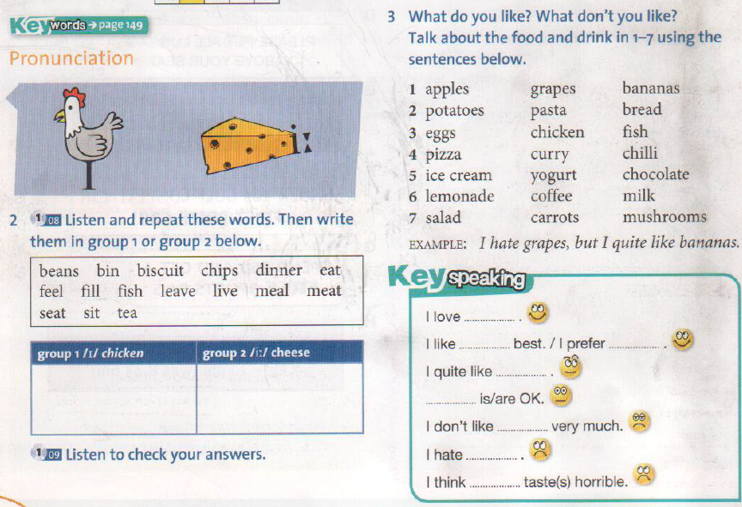

USE. this schema (  /ˈskiː.mə/) …not only for food